Supplementary Figure 1.

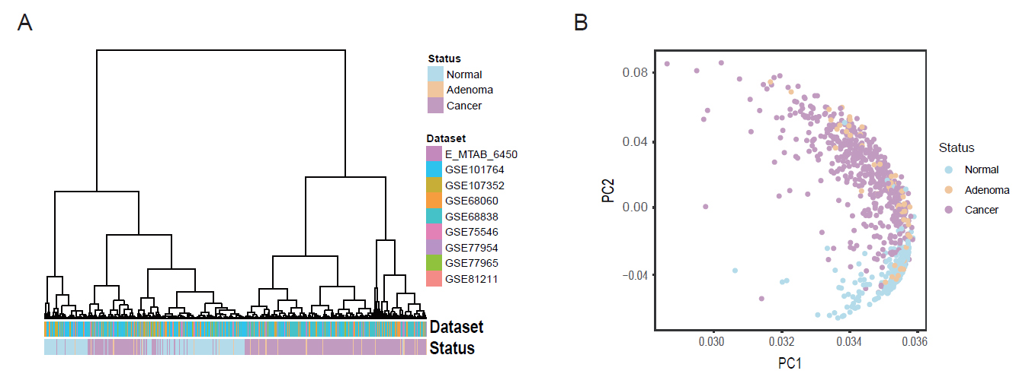

Supplementary Figure 1. All public data of 833 samples cluster and PCA analysis. (A): Cluster analysis of all public data from 9 diverse datasets. (B): PCA analysis of all public sample data shows the pathologic difference surpass batch effect.

Supplementary Figure 2

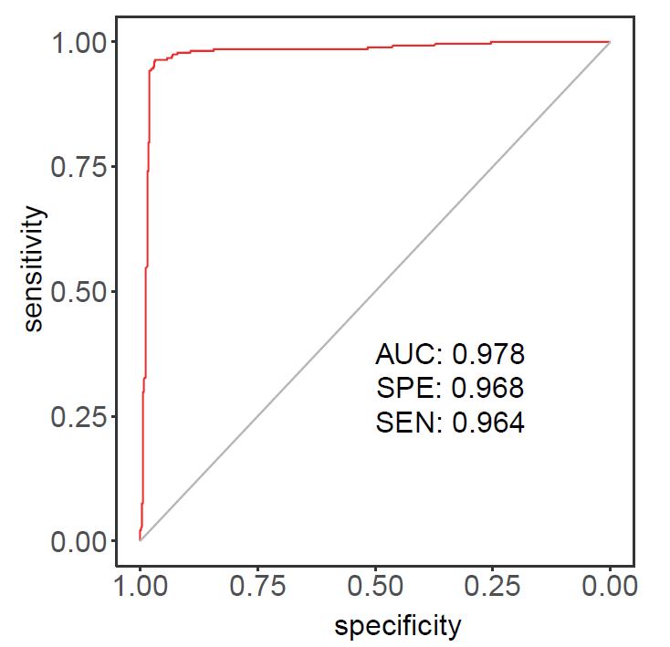

Supplementary Figure 2. Removing adenoma, ROC of the prediction of ADHFE1 for CRC.

Supplementary Table 1. The annotation of different methylation Region of comparison between low-grade adenoma and the normal tissue.

Supplementary Table 2. The annotation of different methylation Region of comparison between high-grade adenoma and the normal tissue.

Supplementary Table 3. The annotation of different methylation Region of comparison between high-grade adenoma and low-grade adenoma.

Supplementary Table 4. The information of in-house data and quantity control.

Supplementary Table 5. The information of all public data.